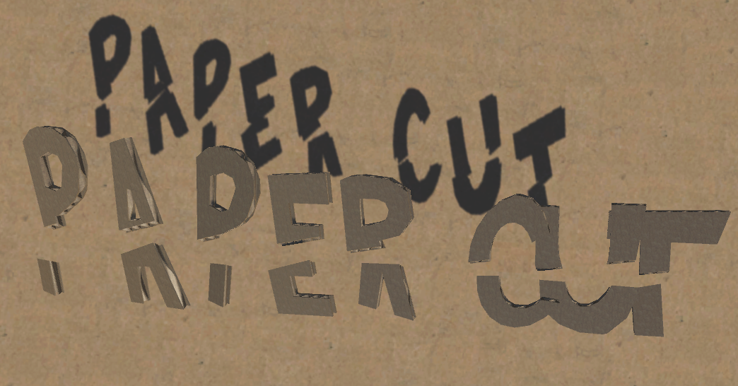  
by

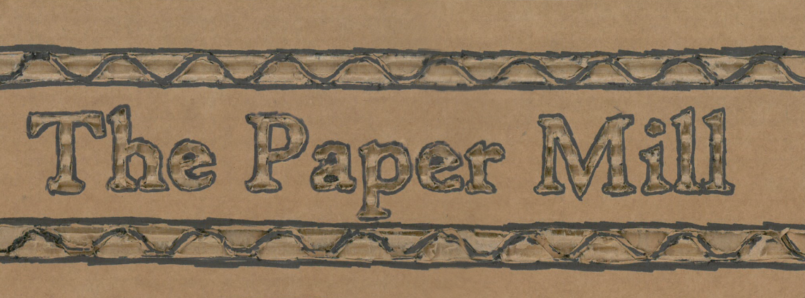

Game Design Document

# DESIGN OVERVIEW

Paper Cut is a game set in a colorful cardboard world!

Players explore a city made of cardboard as they bend, pull, and push cardboard flaps around to alter the environment and solve puzzles.

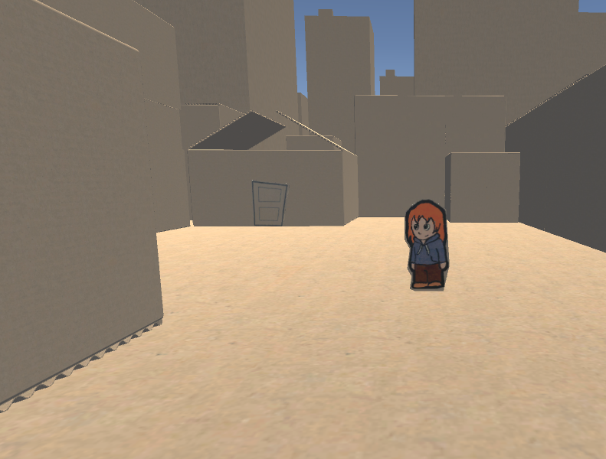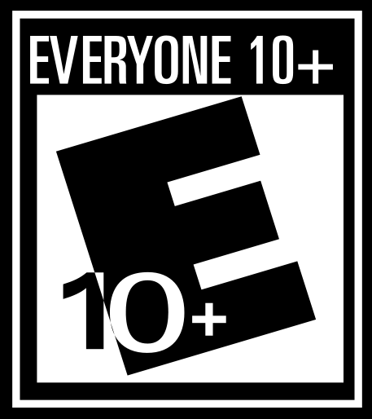

# TARGET MARKET

**Target Audience:**

* Children ages 8–15 years old
* Nintendo and “Light Hearted” game fans
* Platformer genre enthusiasts
* “Core” and “Mainstream” Gamer audience

**How are we focusing on this Market?**

* Simple, easy controls
* Single player experience
* No lose conditions
* Vibrant, colorful aesthetic
* Childish, cartoony art

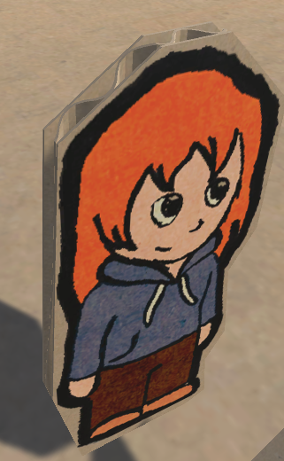

# COMPETITIVE RESEARCH

**PAPER MARIO: STICKER STAR**

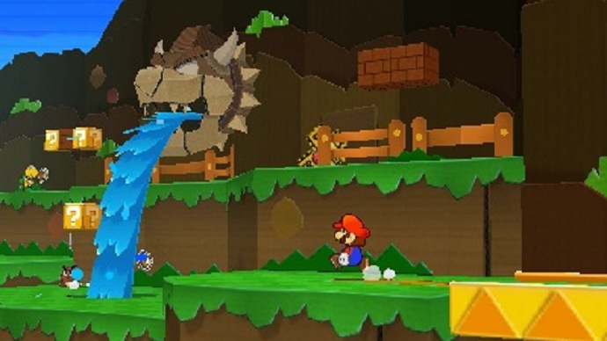

Paper Mario: Sticker Star is a professional title that uses a very similar paper aesthetic, with a distinct focus on simple, colorful environments that are easy for young or newer gamers.  
  
While its characters and environments are paper based, the game mostly uses this as an aesthetic and as a backdrop, and the world and the characters inside make no reference and offer no understanding to their nature. Paper Cut will use paper and cardboard to the fullest, in an attempt to appear “Realistic”, and help ground our player experience and feel. Many parts of Paper Mario do not feel like a cohesive whole. Paper Cut will rectify this by using its aesthetic and nature as more than a backdrop, while using an identically bright color palette and open, simple environments.

# COMPETITIVE RESEARCH

**TEARAWAY UNFOLDED**

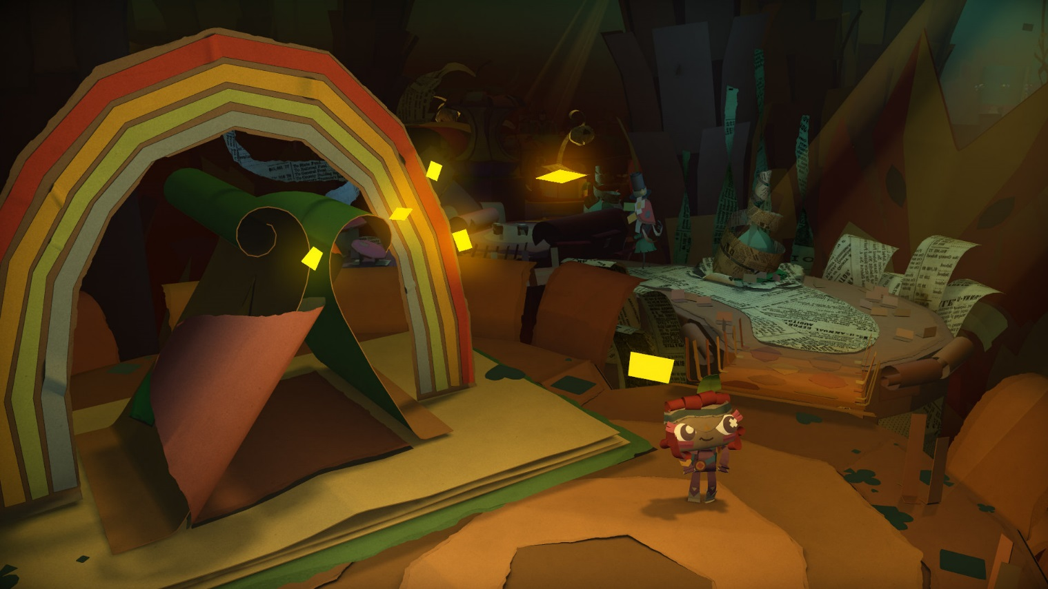

Tearaway Unfolded is a professional title that uses a grounded, realistic paper aesthetic with duller, more realistic colors and mechanics that truly make the world feel like its very core is a world of paper.  
  
Tearaway is a world of paper. This is very similar to what we hope to accomplish in Paper Cut, but with a slightly different aesthetic. We hope to model the interactions our game has in the same way Tearaway does, but with *cardboard mechanics* instead of *paper mechanics*. This allows us a slightly more rigid world and a significantly smaller use of physics, animations, budget, and time, while still drawing in the same target demographics.

# COMPETITIVE RESEARCH

**CARDBOARD KINGDOM**

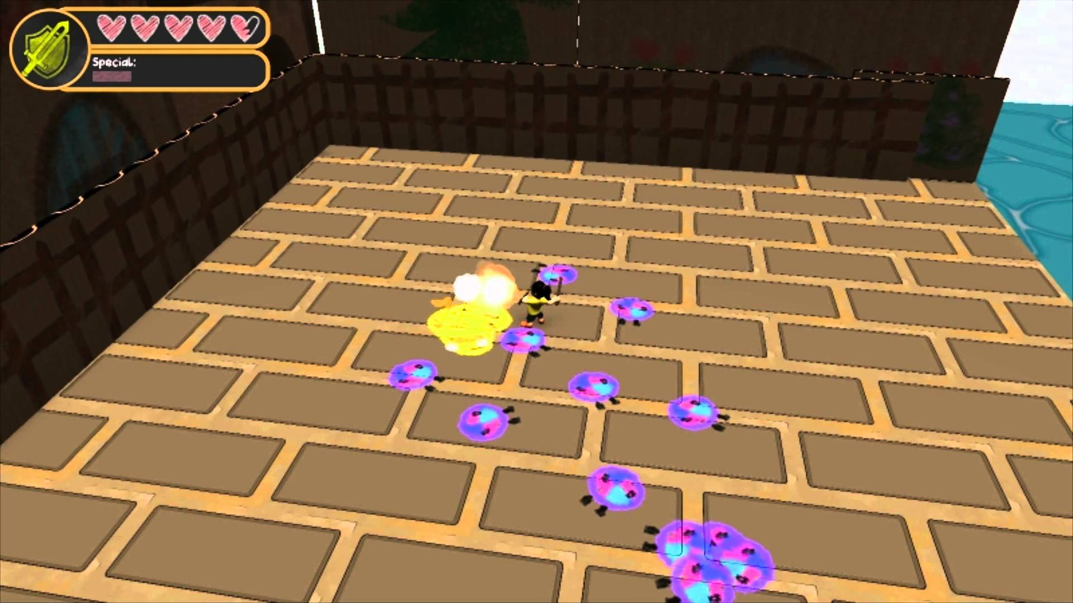

Cardboard Kingdom is a student title produced last year that uses a cardboard environment to emphasize its childlike aesthetic and younger audience demographic.

Cardboard Kingdom uses its theme to get away with blocky environments and simple textures. It illustrates perfectly the pitfalls our project can come across with this aesthetic, and how to combat them. Firstly, Paper Cut is focused on the cardboard nature of the environment. We will use higher-poly, higher quality art assets due to a larger art team, and significantly streamlined art pipeline. Secondly, we will be using a simple, punch-out model method that allows us to create multiple new art assets easily and effectively, and add them into the project. Lastly, we will be using an already existing game engine to expedite level design and iteration instead of relying on a custom built engine. Ideally, this will allow us to create a game in the same vein with a significantly higher production value and quality.

# MECHANICS OVERVIEW

Paper Cut Uses real-world aspects of cardboard to define its mechanics. We utilize various things that cardboard is used for in the real world, such as being a rigid, sturdy substance that can be bent and folded into useful shapes. Players will be able to manipulate the environment with various methods in order to solve puzzles and navigate the environment

**BASIC MOVEMENT**

The player’s avatar will be capable of jumping and moving at any time; this is a fundamental aspect of the 3D platformer Genre.  
  
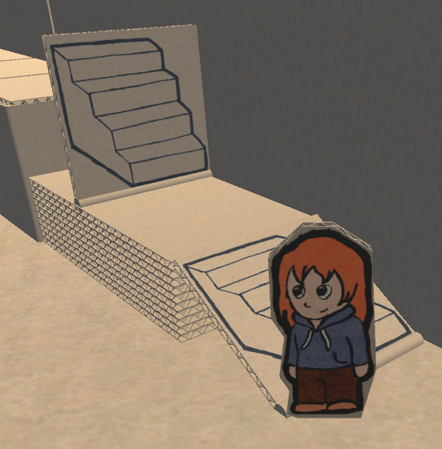**BENDABLE OBJETS**

Bendable Objects are used to traverse the environment to new heights, and are pushed over when stood near. This is an adaptable mechanic that can be used for many different objects with varying size, length, height, and width.

* Bendable object stand on end
* Can be pushed over by the player
* Used as ramps to reach higher areas
* Identified via a large crease in the bottom

**PULL TABS**

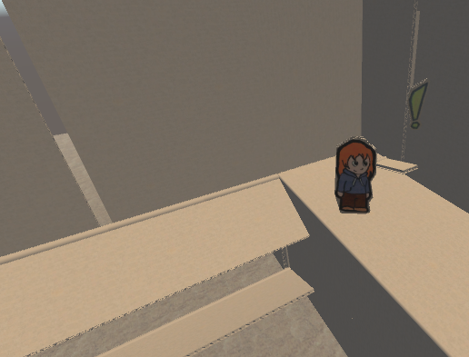Pull Tabs are small tabs that slide along the ground and can be used to alter parts of the environment. This can be used to create drawbridges, make pop-out story books, or move any other object

* Press a button to interact
* Can push, pull, or rotate an object
* Works on things outside of the   
  player’s reach

# C:\Users\i.aemmer\Desktop\gd7.pngCHARACTER OVERVIEW

Like the in-Game objects, Paper Cut uses stiff, single piece of cardboard punched out models for all of its characters. The difference lie in how they act. Most will rotate to pivot to you, and have floating bubbles above their heads to when they are muttering aloud. This will help reveal information to the player and help guide them through the world without requiring them to walk up and press a talk key to engage, although the player can choose to do so to get more elaborate information. Each character has a unique silhouette and have their own unique quest and personality to give the player, helping flesh out the world into a larger setting that it technically is. Characters move by bobbling up and down, while rotating back and forth to mimic a gait of someone with animated body parts, and will act with movements and rotations as if they were in full control of their limbs. Each will have a distinctive mannerism and talk pattern to help distinguish them from each other.

****The main character will be a silent protagonist, much like the characters in other popular children’s series, such as Mario, Link, and Gordon Freeman.

# RESOURCES OVERVIEW

**Art Assets**

The project will use Scanned images drawn in paper with sharpie to help solidify the Cartoon child-friendly art style. After being scanned into the computer, the image is “Punched out” of an existing Maya cardboard model file, and the textures are edited simply in Photoshop. Unity itself handles the merging of the two. There are three basic Game Object types in Paper Cut

**Script Objects**

Scripted Objects are any major prefab or game object that has specific, unique code. Things like the player spawner, Level entrances or exits, or even invisible systems like the interact manager or a collider game event trigger are all scripted objects. These are stored separately because the majority of them are invisible and do not have distinct Art Assets (At least not ones that can be seen outside of the editor). They are represented by see through white boxes.

**Background Objects**

Background Objects are any major prefab or game object that exists to be stood, walked on, or pushed against. These are giant constructed objects like buildings, boxes, skyscrapers, and the ground. Typically they are static and won’t move, although some can have parts that can be interacted with, such as the doors. 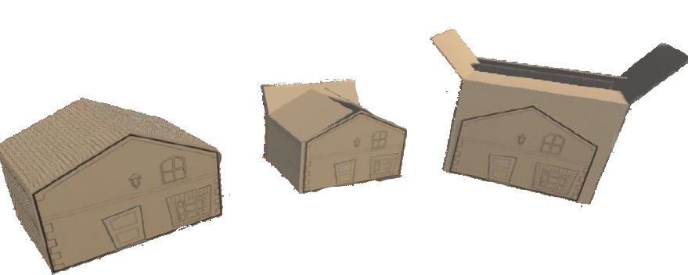

# RESOURCES OVERVIEW

**Prop Objects**

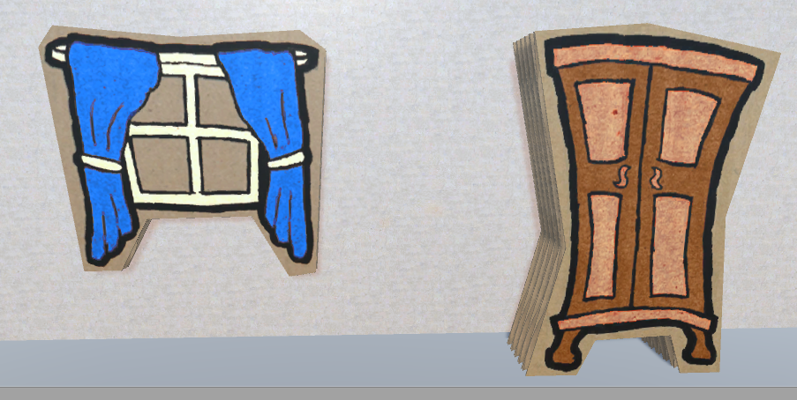Prop Objects are any objects that stay still and snap to a “Wall” or ground surface. Their purpose is to decorate the back ground objects and bring life to the game. These will be the most numerous of the art assets and never have code attached to them outside of a game collider.

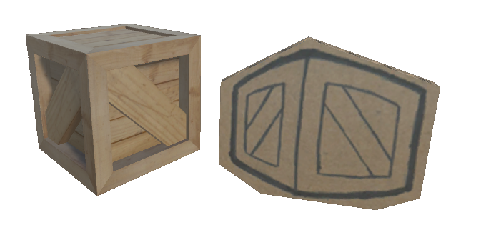**Item Objects**

Item Objects are Narrative-Specific game objects that require two models. The first will be made of cardboard and the second will be made of “Real” world materials, mimicking real life. The player will use both of these items and change them back and forth through the gameplay in order to reach new areas.

**Code Assets**

The project will use C# and visual studio to write base game code. On top of Unity’s pre-provided systems, the game will make use of four major systems.

**Action System**

We have implemented an advanced Action System that allows our objects to move smoothly in various eases around the game level. This is Unique from Unity’s default action system and makes our character’s movements, and the interactions in the environment look more realistic.

# RESOURCES OVERVIEW

**Interact System**

An Interact System has been created that allows designers to attach a simple script to a game object and turn that game object into an “Interesting” Game object. The interact system handles user interaction and tracks changes in state, allowing the game object to talk, inspect, move or give, take, and react to things the player does when inspected or interacted.

**Event System**

We have implemented an advanced Event System to replace Unity’s default Event System. Ours can take in not only game objects, or scripts, but also specific functions, custom events, and handle broadcasting at a faster and more efficient rate than normally allowed.

**Talk System**

To interface with the Interact System, a Talk system handles all aspects of game objects that react by “Talking”. This allows an NPC to request or give an item to the player, simply talk or expose helpful hints, or can allow non NPC game objects to be described in detail when inspected. This system helps make the world come alive and is as simple as attaching the talk and interact component to a game object.  
  
**Level Editor Tools**  
We have developed several level editor tools, including a Snap-Grid design, which allows game objects to line up perfectly without conflicting geometry, plop straight into the level from the editor window matched in the perfect orientation. Additionally, we have a “Bend” system that allows parts of the level geometry to bend into shape when pushed by the player, and a “Pull Tab” system that allows the player to bend or push a part of the environment at a distance, along a slider. These tools link simply to the various game objects in the project, based on their similar model skeleton.

# RESOURCES OVERVIEW

**Sound Assets**

The project will use prebuilt FMOD integration frameworks, with Bank file and compressed .MP3s for Music and .WAV files for Sound Effects

**Music**

Paper Cut will feature an upbeat, friendly audio style mimicking Saturday morning cartoons and other lighthearted mediums, to focus on our target demographic. The files will be imported into FMOD to allow us to change the parameters of the music at runtime. When a player walks into a building, the music will shift to a more muted, version of the song playing outside in the street. As the player progresses through the levels, each room will have a slight variation on the music by using these parameter swapping variables.



**Sound Effects**

Paper Cut is made exclusively using the Hollywood Cartoon Sound Effects license, combined with extensive custom cardboard foley produced by the sound artists. The two are blended together to give a familiar cartoon feel with the distinct “I am in a cardboard world” effect.



**Voice Overs**

When talking, NPCs will give a distinct visual voice cue, made entirely of gibberish in the style of Banjo Kazooie, The Sims, or Little Big Planet. These will be repeated, remixed, and pitched down, and so that different NPCs feel like they have a broad variety of speech language. These voices will be remixed vocals recorded by the sound artists.



# ENVIRONMENTS OVERVIEW

Paper Cut is a world made of cardboard, and the entirely of the environment and the game objects and characters will be made out of cardboard using premade Cardboard Blocks. There are two different environment types that will be encountered in Paper Cut.

**Indoor Environments**

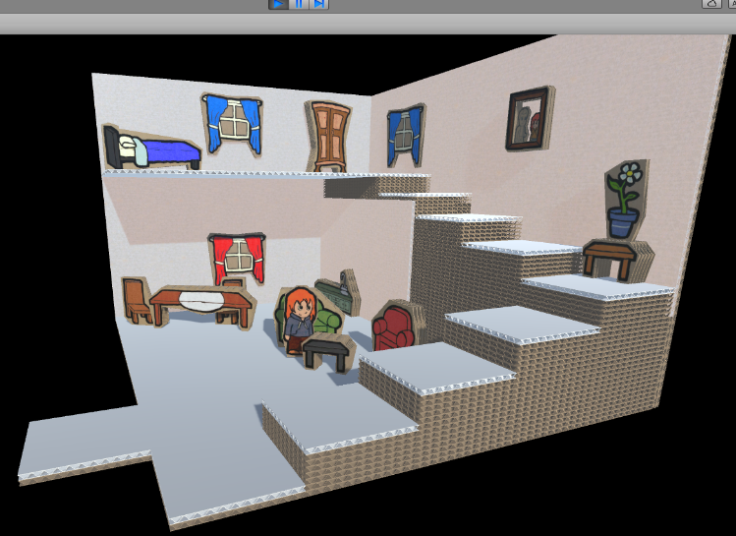Indoor Environments are small, clustered environments that are dead ends in the environments and more help to illustrate a solid area where there otherwise wouldn’t be in the world map. They are highlighted by a solid black outline covering the outside world as the player walks in, in contrast to the brighter outdoor environment. Entrances and exits are identified by a large 1x1 tab sticking out of the ground.

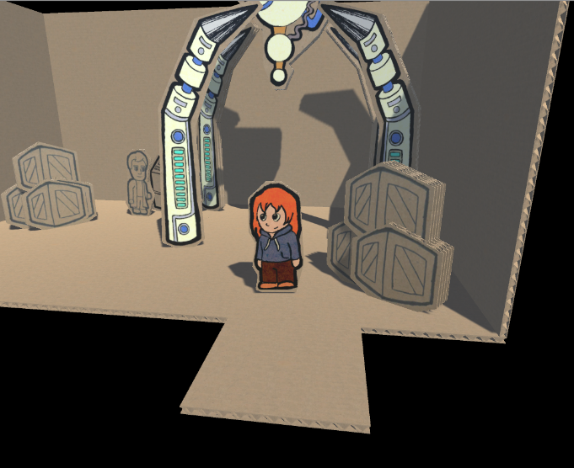

**Outdoor Environments**

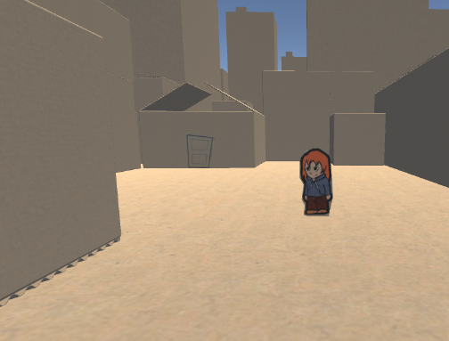Outdoor Environments are open expanses that have one or more entrances and exists, and usually have puzzles and other things to interact with, and serve more than one purpose.

# INTERFACE OVERVIEW

Show/describe the nature of the controls/HUD for the game.

Paper Cut is intended for a younger audience, so the controls are simplified to movement, interact, jump, and pause. There is also slight camera control, but that only tweaks direction and is not needed to play the game.   
  
Paper Cut is intended to be played on a controller , but is also playable on keyboard.

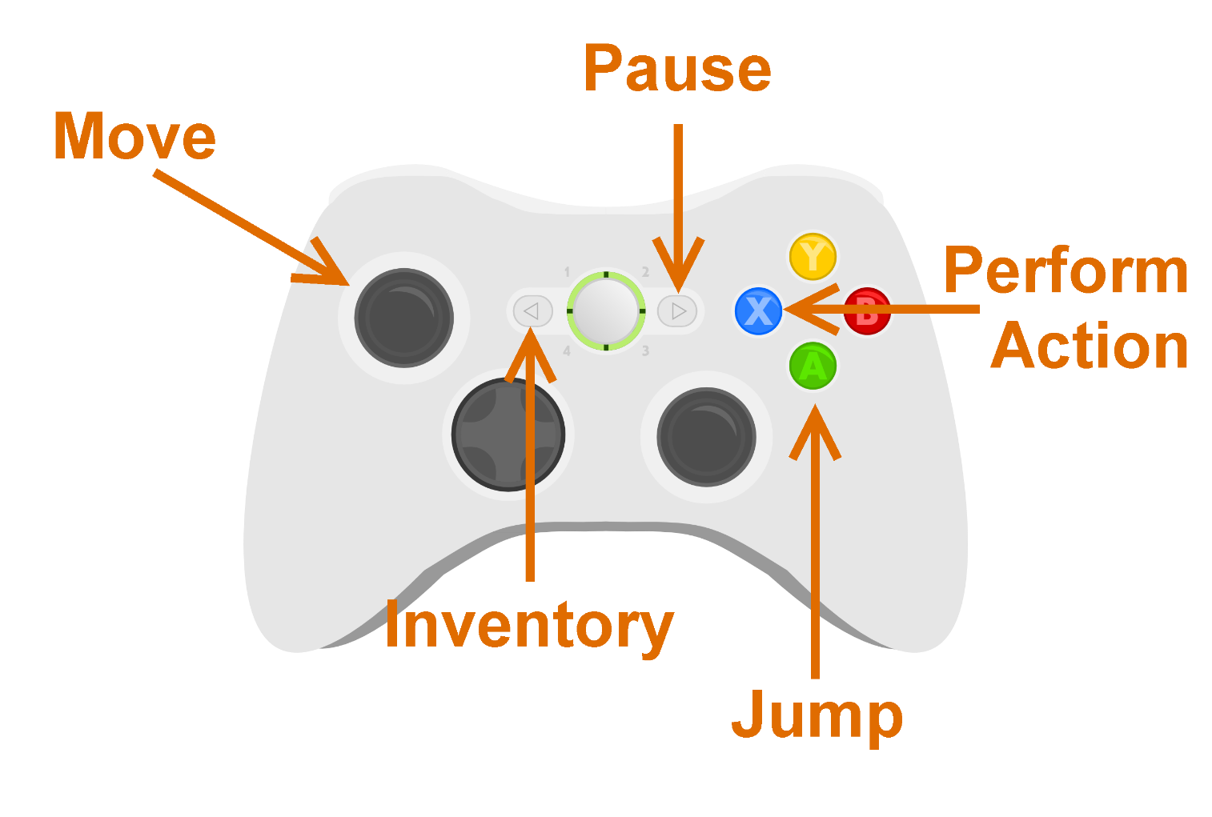The Keyboard Controls support WASD and Arrow Keys, using “e” and Enter to interact, with Spacebar to jump and Esc to pause. The mouse operates the same as the right stick of the controller, subtly moving the camera but otherwise being unnecessary.   
  
Menus are navigable with both keyboard, controller, and mouse.

# NARRATIVE OVERVIEW

Describe/show the nature of the narrative the game will have.